Talal Jawaid

11/24/19

Lab 5

SQL Injection

Sql injection is complicated technique that has been used from the dawn of sql to send custom sql queries to unsanitized inputs to retrieve or manipulate data from databases that are not meant to be accessible.

First step is to launch apache webserver

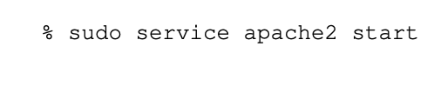

You then have to modify hosts file to map domain names to web servers ip address.



We then configure sources for website by modifying sources in directory it is hosted in

As there are built in countermeasures, we have to disable the PHP mechanism “magic quote.”

As the VM we are using does not include the employee management web app for this lab, we have to patch the VM

Bootstrap script will patch by adding db called users in the vm, load data into the db, set up virtual host URL, and modifies DNS config.

At this point, the db should host this data. The goal is to access it.

As in previous labs, we can just log in to our mySQL

This is the web app

We then have to access using the SQL injection attack

This screen, while innocuous, allows us to submit SQL commands

By using countermeasures, we can prepare against the SQL injection attack

I noticed this is very similar to the SQL injection techniques on hackthissite, which was a very valuable resource in understanding SQL injections for this lab.